Our class eats snack at 9:30 during Social Studies, before Specials. Thank you for sending a healthy snack for your child to enjoy in the classroom.

Fruits & Vegetables

- Apple slices
- Bananas
- Blueberries
- Cherries
- Grapes (red, green, or purple)
- Oranges
- Raspberries
- Strawberries
- Raisins
- Fruit leather
- Broccoli
- Carrot sticks or Baby Carrots
- Celery Sticks
- Snap Peas
- Tomato slices or grape or cherry tomatoes
- Yellow Summer Squash slices
- Zucchini slices
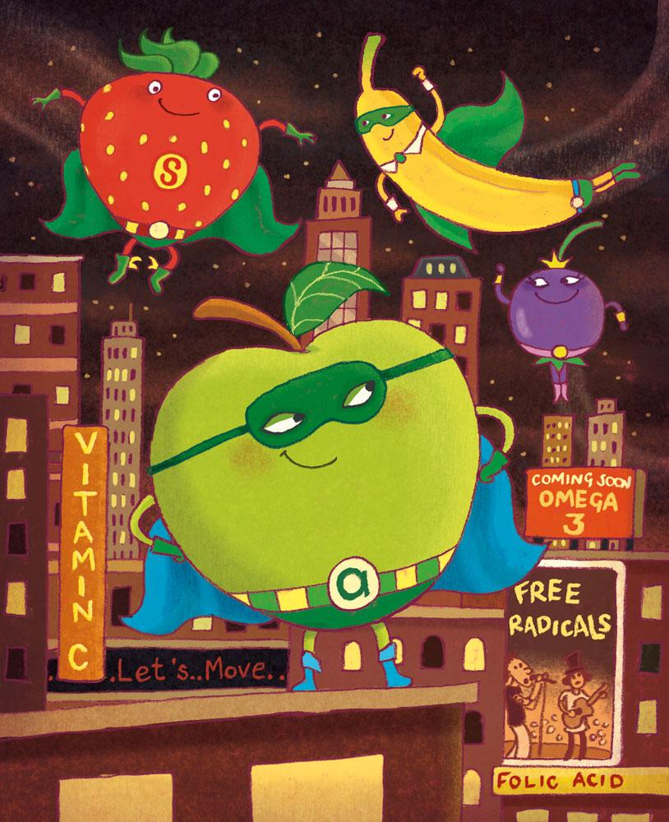

Healthy Grains

Crackers
- Goldfish
- Graham crackers (not cookies!)
- Triscuits
- Wheat Thins
- Other whole grain crackers
Rice cakes
English muffin
Pita
Popcorn
Pirate’s Booty
Baked chips
Pretzels

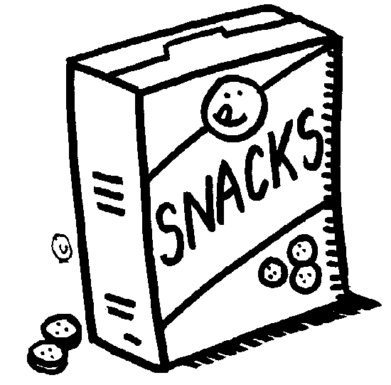

Thank you for choosing to send healthy, low-sugar snacks for your child. You are welcome to bring other fruits, vegetables, or healthy grains not on this list. Please remember to pack snacks separately from your child’s lunch. Thank you for saving any fruit juice, yogurt, or other potential “messy” snacks for lunch rather than for our class snack time.

Water is the only drink allowed in the classroom. Juice, milk, and sports drinks are allowed for lunch in the cafeteria.

